Monte-Carlo Simulation of Portfolio Risk

Research and Reading Resources:
- https://medium.com/codex/measuring-portfolio-risk-using-monte-carlo-simulation-in-python-part-1-ac69ea9802f
- https://medium.com/codex/measuring-portfolio-risk-using-monte-carlo-simulation-in-python-part-2-9297889588e8
- https://thepythonlab.medium.com/building-a-python-framework-for-stress-testing-financial-portfolios-38d013f2af41
- https://freedium-mirror.cfd/https://thepythonlab.medium.com/building-a-python-framework-for-stress-testing-financial-portfolios-38d013f2af41#bypass

Introduction

Hence , I will try my best to explain the concept of Monte Carlo simulation and why is it an important method for portfolio risk management and an important method used by major players in the financial field.
As data scientists, we always have the task to deal with uncertainties and be prepared for unexpected situations, by simply predicting the risk associated with every event we try to pursue , or achieve.
Imagine, you are managing a list of stocks or a portfolio where your investment mandate is simply to achieve capital growth and mitigating your risk at the same time.
Monte Carlo Simulation method is used to account for risk in quantitative analysis and decision making. To sum it up , this method is used by professionals in fields of finance, , energy , project management , oil &gas , transportation , ESG and in many more sectors.

Monte Carlo Simulation in a Nutshell

Monte Carlo simulation performs risk analysis by building models of possible results, by simply substituting a range of values — called a probability distribution — for any factor that has inherent uncertainty. In simple terms, Monte Carlo model is used to predict the probability of different outcomes or in our case portfolio value based on different volatilities results from all stocks in question. The outcome of this model will explain the impact of risk and uncertainty in prediction and forecasting models. These risks will be presented in form of cVar and Var values.

Basically , Monte Carlo model builds models of possible results by substituting a range of values presented in the model in a form of probability distribution , for any factor that has inherent uncertainty. Then, it calculated and run these results over and over again, where each time using different set of random values from the probability function.
Based on the number of uncertainties in question, the model could involve hundreds or thousands of recalculation before its complete.

Covariance and its relation to Monte Carlo Simulation

Calculating covariance of two randomly variables or returns is a major component for the monte carlo simulation method. Covariance evaluates how the mean values of two random stocks move together. If stock A’s return moves higher whenever stock B’s return moves higher and the same relationship is found when each stock’s return decreases, then these stocks are said to have positive covariance.
Why are we using Covariance as a measure of risk in our Monte Carlo method, because simply in modern portfolio theory we use covariances to statistically reduce the overall risk of a portfolio by protecting against volatility through covariance-informed diversification.

Dataset

For the historical data that we will be using for our Monte Carlo simulation, we will be forming our basket of stocks from the following tickers:
- 'BNS.TO', 'GOOGL', 'XOM', 'NIO', 'KO', 'PEP','ARCC','IBM','AGNC','LCID'

Which can be retrieved from YahooFinance

A well-established and constructed portfolio usually consists of a collection of stocks, bonds, commodities, futures, and derivatives. The allocation of values or investments for these asset classes is determined by a fund manager who must follow a strict investment mandate based on the company’s investment objection that he or she works for.

As for the duration of our analysis, we will be measuring our portfolio risk based on the 300 days performance of all these stocks

Step-by-Step Monte Carlo Simulation Code Breakdown

Here is a sample code for Monte-Carlo Simulation. Let us walk through what each line does

# Monte Carlo simulation
mc_sims = 100 # number of simulations
T = 100 #timeframe in days
meanM = np.full(shape=(T, len(weights)), fill_value=meanReturns)
meanM = meanM.T
portfolio_sims = np.full(shape=(T, mc_sims), fill_value=0.0)
initialPortfolio = 47000
for m in range(0, mc_sims):
Z = np.random.normal(size=(T, len(weights)))#uncorrelated RV's
L = np.linalg.cholesky(covMatrix) #Cholesky decomposition to Lower Triangular Matrix
dailyReturns = meanM + np.inner(L, Z) #Correlated daily returns for individual stocks
portfolio_sims[:,m] = np.cumprod(np.inner(weights, dailyReturns.T)+1)*initialPortfolio
font = {'family': 'serif',
'color': 'white',
'weight': 'normal',
'size': 25,
}
plt.figure(figsize=(20, 10))
plt.plot(portfolio_sims)
plt.ylabel('Portfolio Value ($)', fontdict=font)
plt.xlabel('Days', fontdict=font)
plt.title('Monte carlo simulation of a stock portfolio', fontdict=font)
plt.show()

First, we define the number of independent MC paths we want to simulate (mc_sims), Each path represents a possible future evolution of the portfolio. For each simulation, we define the duration or time horizon (measured in trading days), which we will store as a value in (T).

Second, meanReturns is assumed to be a vector of expected daily returns for each asset. np.full(…) replicates the mean returns across all T days. Shape before transpose: (T, number_of_assets) .T transposes it to (number_of_assets, T) so dimensions align later.

Conceptually, this assumes stationary expected returns across the simulation horizon. Each asset has the same expected return every day.

Third, we initialize our portfolio simulaton to be np.full(shape=(T, mc_sims), fill_value=0.0)
- Pre-allocates a matrix to store portfolio values.
- Rows → time (T days)
- Columns → simulation number (mc_sims)
- This improves performance and gives a clean structure for plotting and risk analysis later.

We will also start with a portfolio value, which in the above case, is $47,000

Four, we will iterate through our simulations. For each simulation:

- We will generate random shocks represented by Z = np.random.normal(size=(T, len(weights))), which is a set of independent standard normal variable with a shape of (T, len(weights). These shocks represent random market movements before correlation is applied.

- We apply the Cholesky Decomposition via L = np.linalg.cholesky(covMatrix). covMatrix is the empirical covariance matrix of asset returns and the Cholesky Decomposition factorises into

$$Σ=LL^{T}$$

Where $L$ is the lower triangular matrix. This is the key step that introduces realistic cross-asset correlation into the simulation

- Next up, we find the correlated daily returns for the individual stock, which is meanM + np.inner(L, Z). np.inner(L, Z) transforms uncorrelated shocks into correlated shocks. This ensures:
- Volatility matches historical estimates
- Correlations between assets are preserved
Adding meanM shifts returns from zero-mean to expected-return-adjusted values.

- We will compute the portfolio value path and store it into our variable via the following line portfolio_sims[:,m] = np.cumprod(np.inner(weights, dailyReturns.T)+1)*initialPortfolio.

np.inner(weights, dailyReturns.T) computes portfolio daily returns as a weighted sum of asset returns. Adding a 1 converts returns into gross returns. Multiplying it by initialPortfolio scales the return path to dollar values. The result is one full portfolio value trajectory stored in column m.

As a quick summary follow the steps below for Monte-Carlo Simulation

- Estimate Inputs
  - Compute historical mean returns, volatilities, and covariance matrix.
- Generate Random Shocks
  - Simulate uncorrelated random returns using standard normal variables.
- Impose Correlation Structure
  - Apply Cholesky decomposition to introduce realistic dependencies.
- Construct Asset Return Paths
  - Add expected returns to correlated shocks.
- Aggregate to Portfolio Level
  - Combine asset returns using portfolio weights.
- Apply Compounding
  - Convert returns into portfolio value paths over time.
- Repeat Across Simulations
  - Generate many scenarios to build a distribution of outcomes.
- Analyse Risk
  - Extract VaR, CVaR, drawdowns, probabilities of loss, and stress behavior.

Determination of Worst-Case Scenario
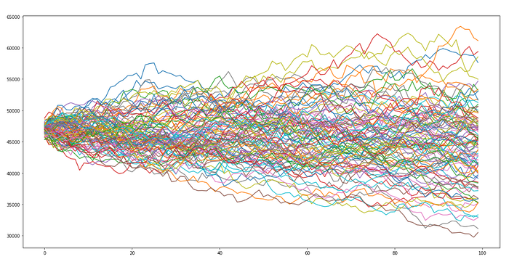
A sample MC simulation of 100 different portfolios is plotted above, We can closely see the initial portfolio amounts are at the USD 47,000 mark. Hence, in the next 100 days, the portfolio should be valued at over USD 63k or shouldn’t drop below USD 30k.

To determine the worst-case scenario for your portfolio, we need to dig even deeper in our code and figure out the VAR and cVar value, which will tell us how much we might lose in case the market or the portfolio tanked or dropped to a certain level. Basically, Var and cVar are concepts that are used in the field of financial risk measurement to evaluate the market risk or credit risk of a portfolio.

VaR and cVaR

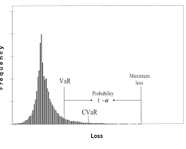

VaR (Value at Risk) is a statistical method that quantifies the extent of possible financial losses within a portfolio, organization, or position over a specific time frame, while cVaR (Conditional Value at Risk) known as the expected shortfall, is a risk assessment measure that quantifies the amount of tail risk an investment portfolio has.

cVaR is calculated by taking a weighted average of the extreme losses in the tail of the distribution of possible returns, beyond the value at risk (VaR) cutoff point, in another word, cVaR will give you the value of losses for the worst-case scenario of your portfolio or position. Hence, cVaR value tends to be mathematically larger than VaR , that’s why a Fund manager will always consider the readings from both Var and cVaR to optimize and measure risk for effective risk management.

Stress Testing and Scenario Analysis

Cholesky decomposition is a decomposition of a Hermitian, positive-definite matrix into the product of a lower triangular matrix and its conjugate transpose, which is useful for efficient numerical solutions

